**REQUIREMENTS**

**ANALYSIS DOCUMENT**

**STUDENT MANAGEMENT SYSTEM**

**CONTENTS**

1. Vision
2. Problem Description
3. Requirements
   1. Functional Requirements
   2. Non-Functional Requirements
4. Use Cases
5. Domain Model
6. System Sequence Diagram
7. Glossary
8. **Vision:**

The Student Management System coordinates the timing and communication between faculty members regarding students. This system exists to facilitate information tracking for both students and administrative staff. In addition, courses and curriculum are determined, students can see their grades, and include student, instructor information.

1. **Problem Description**:

The problem is the software implementation of course registration and course passing processes during the undergraduate programs of the students. Solving problems such as course conflicts, taking courses from previous or next semesters, credit problems, course pass status checks encountered during the course registration process.

1. **Requirements**:
   1. ***Functional Requirements:***

- Registers new students.

- Register lessons and labs for a particular semester.

- Records the course details and subject information.

- Records the number of students attending to courses.

-According to syllabus, sets the course limit for students.

- Records the attendance of students.

-Assigns an advisor to each student.

- Advisors arrange schedule of the students according to rules stated.

- Considers only solid lines in prereqrusite tree.

- Records the grades of students.

- Considers final grade and total course grade

-Advisor allows course selection based on the curriculum and student’s total credit

-Calculates the grade point average of the students for each course and determines the letter grade.

-Calculates the pass grade for each course.

-Determines the pass or fail status according to the student's grade.

-Simulates the registration process for all students.

* 1. ***Non-Functional Requirements:***

- Performance:

The performance of the functions and every module should be well.

- Scalability:

The system should be able to handle inputs of varying sizes.

- Compability:

The system must be platform independent.

- Reliability:

Output given by system should not be too different.

- Maintainability:

The system is sustainable.

1. **Use Cases:**

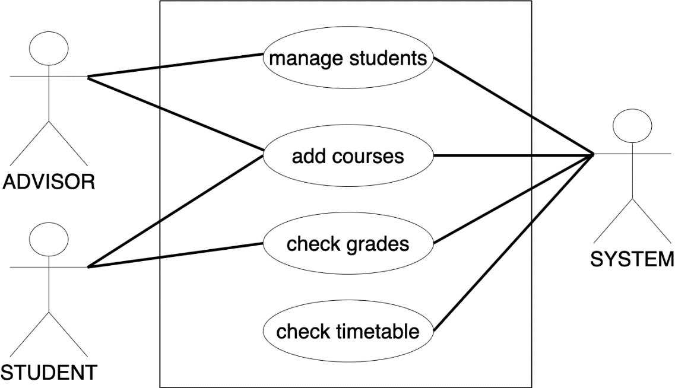

1. **Domain Model**:



1. **Systems Sequence Diagram:**

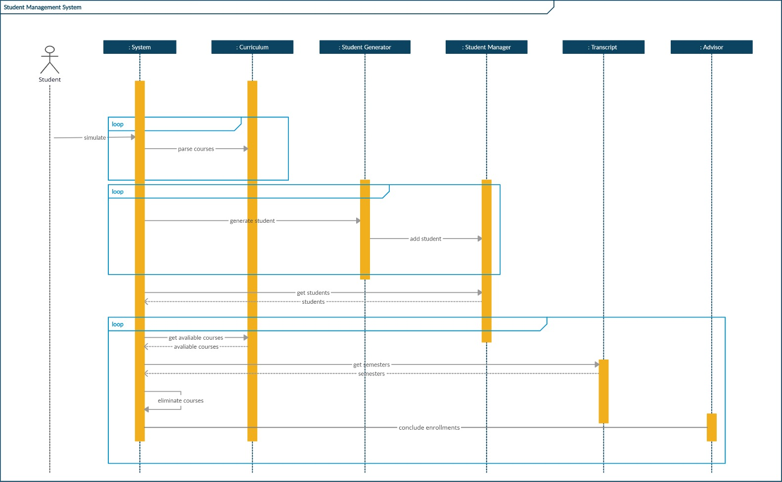

1. **Glossary:**

-Advisor:

Arrange schedule of the students.

-Student:

Chooses the course.

-Student Semester:

Shows the grades of the student's current period.

-Pass Grade:

The minimum score a student must achieve to pass this course.

-Curriculum:

It holds the courses that must be taken for all semesters.

-Transcript:

It shows the grades for all semesters passed by the student and calculates the grade point average.

-Generator:

Generate students.

-Enroll:

Enrolls students in courses.